Table of Contents

Problem Overview 2

RELEARN – Adult maths app. 2

Existing Systems: 4

Layout/Structure 4

Main Features: 4

Existing Systems: 6

Assessment/Progress 6

Feedback 7

Classes 8

User Prototypes 9

# Problem Overview



# RELEARN – Adult maths app.

The problem we have chosen to solve is for adults that have had struggles with mathematics whether that be due to inefficient education, having to delay education or occurrence of a traumatic experience. We believe all people, even those who are of older age should have the resources to be able to learn simple/basic mathematical skills.

The evolutionary process is a method that will allow us to provide the users with a product they can test out since their input and feedback on the product will be very important in the design process and the overall UI and features of the product.

# Personas:

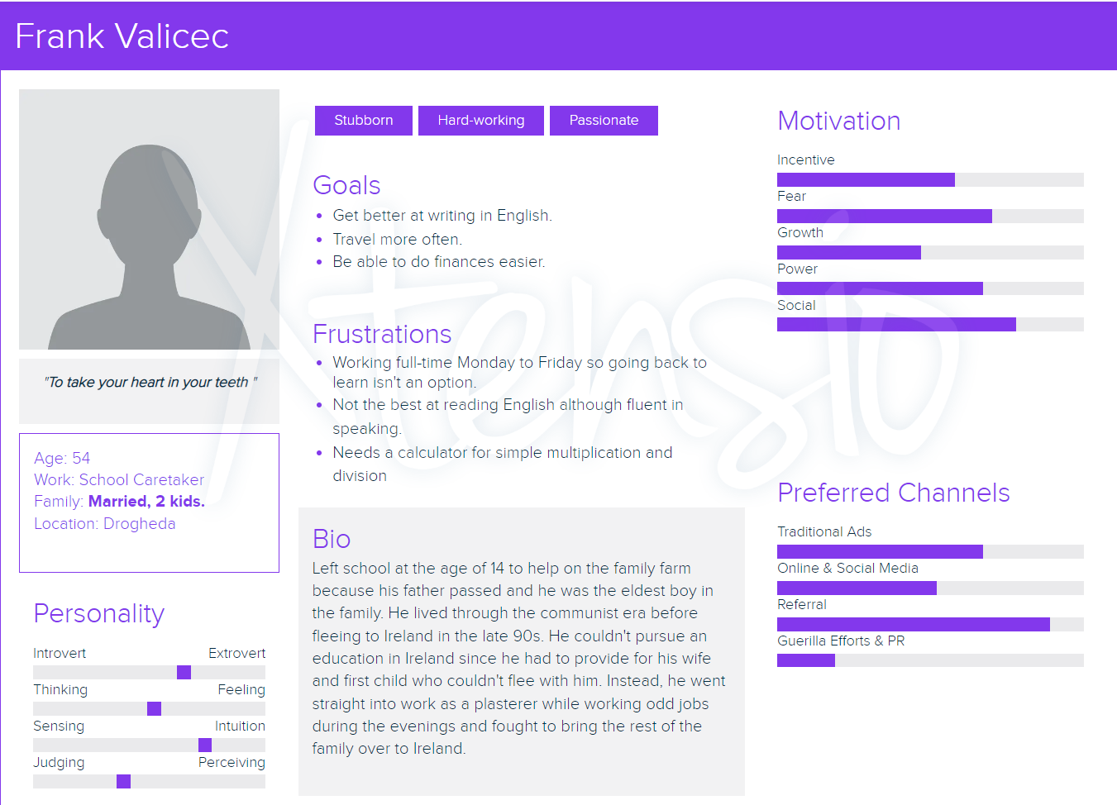

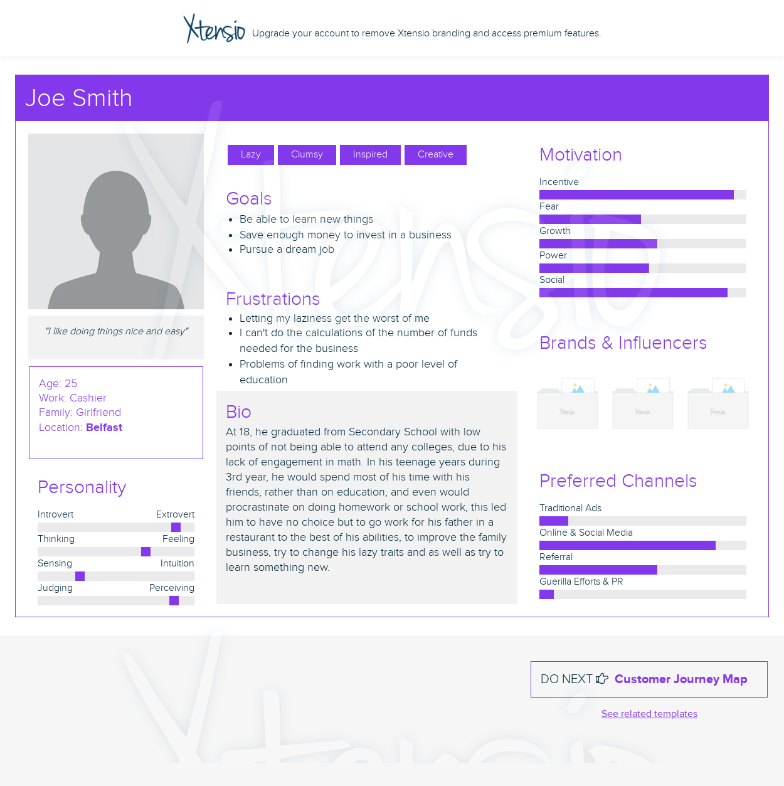Must need requirement: Audio function.

Needed requirement for this persona is interactive questions

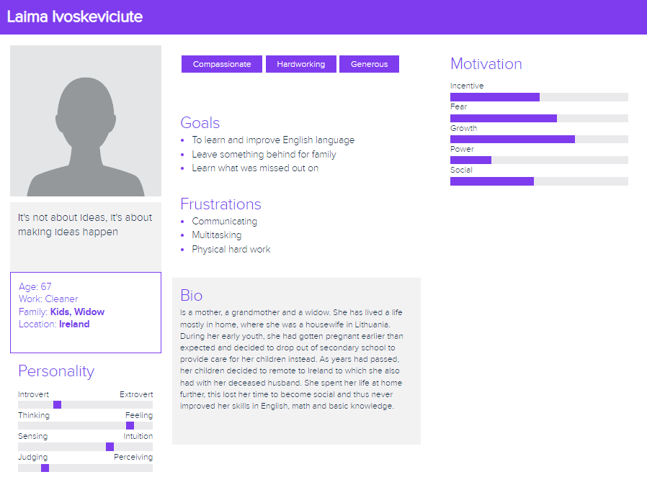

Needed requirement for this persona is images on questions, visual learning implementing.

*Requirements Elicitation*

(** means what we would do different)

# Existing Systems:

* Khan academy

# Layout/Structure

Choices of options between what type of user you are.

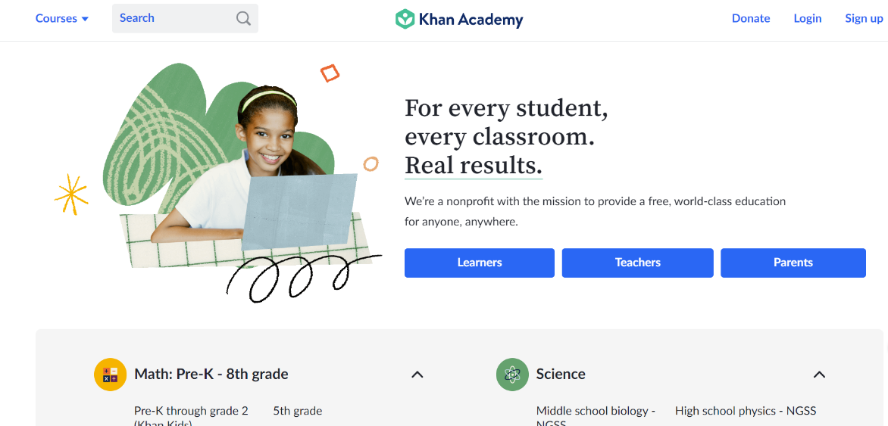

# Main Features:

* Contains a list of different types of learning scales/difficulties according to user’s education and or other.
* ** add images for nonnative speakers to understand the math’s age group or a drop down

menu to select country and the equivalent grades in that countries would pop up.

* It has step by step process of each mathematical concept that you will start with, be introduced to and be given before moving onto other chapters of the course.
* **Create it more user friendly
* Has videos added to the course throughout the website, containing information on step-by-step process of a specific concept.
* **Add videos to the website as well, easier to understand for those who don’t speak English by using more animated and slow-paced visuals.

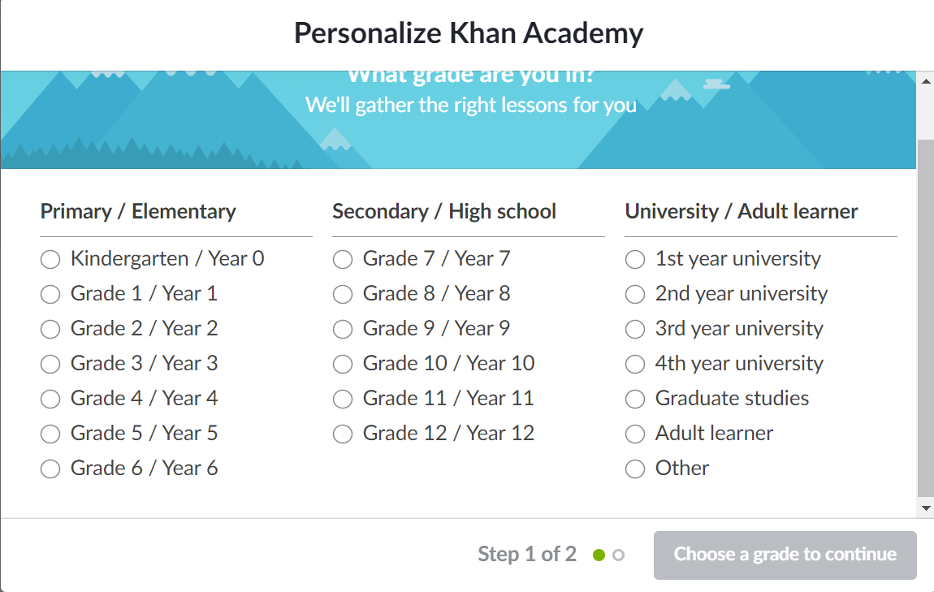

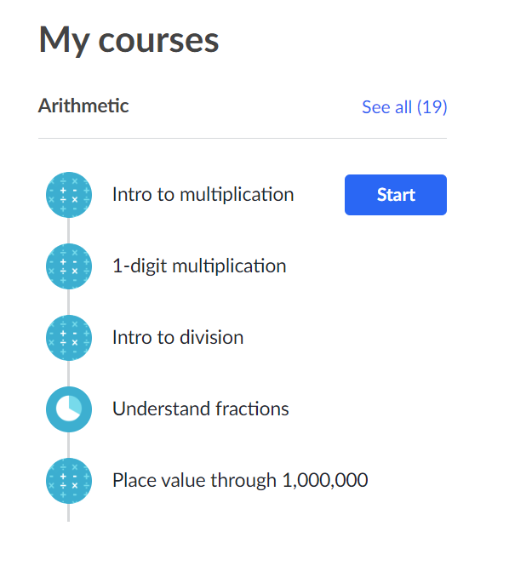

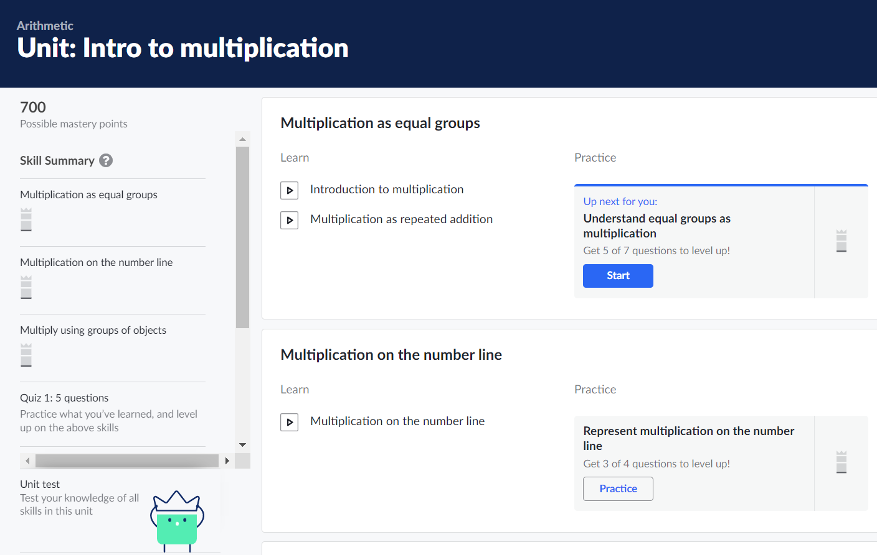

Existing Systems:



Brilliant:

-Behind a pay wall

-**no payment required

# Assessment/Progress

Khan Academy's progress:

* Has a point system
* **consider having this implemented with a bar of progress
* They also have a progress area that is calculated by percentages of how many were correct and how many were incorrect.



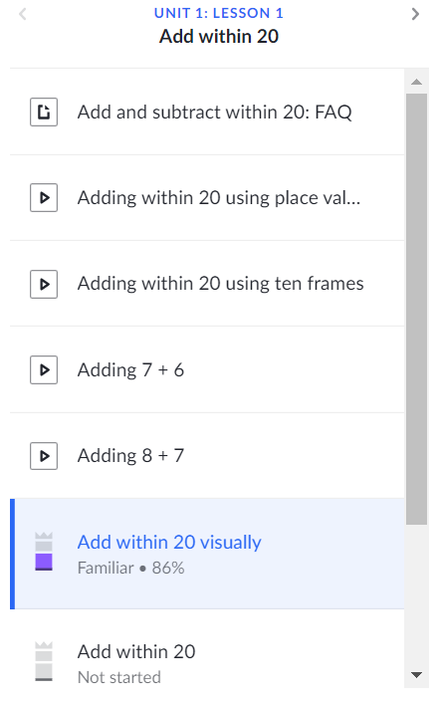

# Feedback

* Comment section for other users to give answers to questions. Allowing other people to ask for help in the comments if content is difficult to understand or type a certain question that may be difficult and be provided with other’s help.
* It is motivating, tells you are doing a good job.
* Allows you to see correct answer if answered correctly or incorrectly

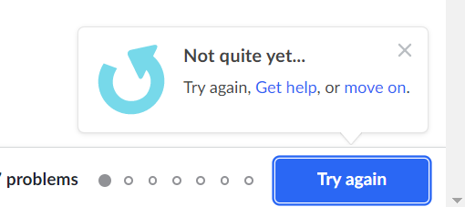

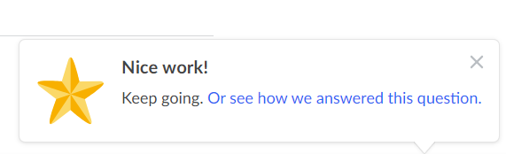

Our Plan for Requirements for Personas and Website

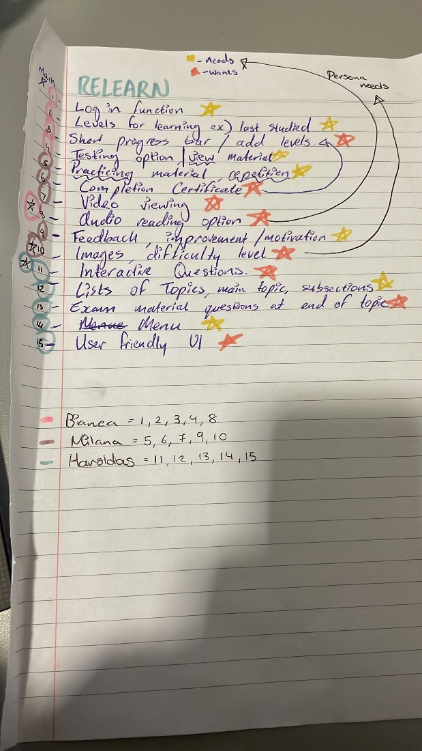

# Classes

Rough outline for our built classes, including attributes as well as functions.

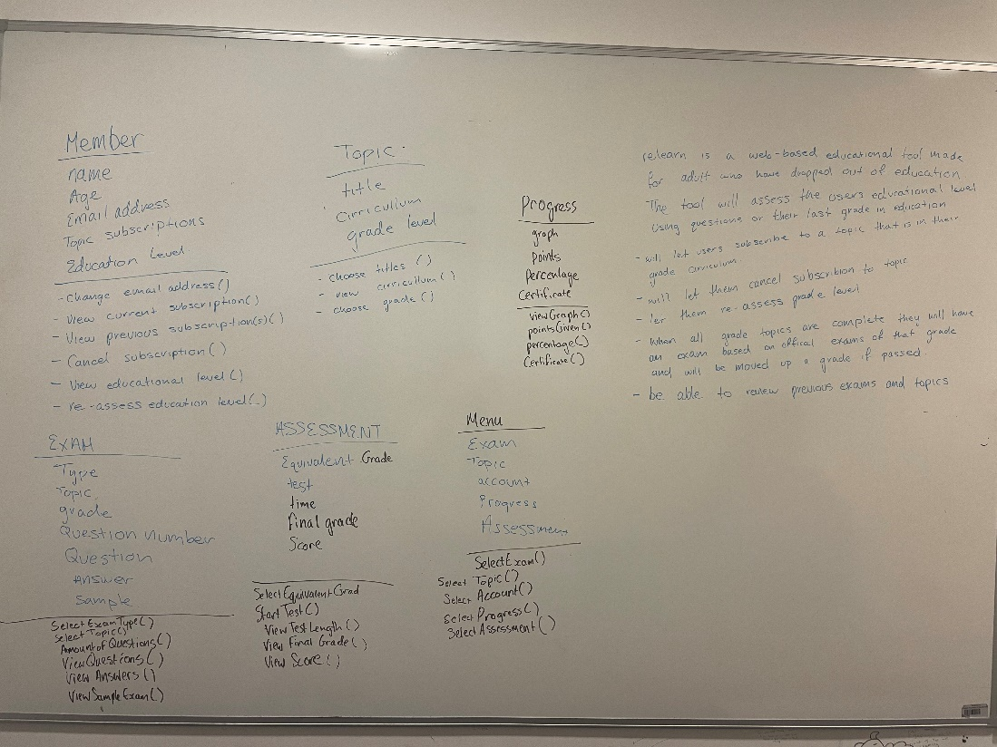

We were able to identify 5 main classes within our product, although they could be more classes, we decided to focus on the main big classes we could identify.

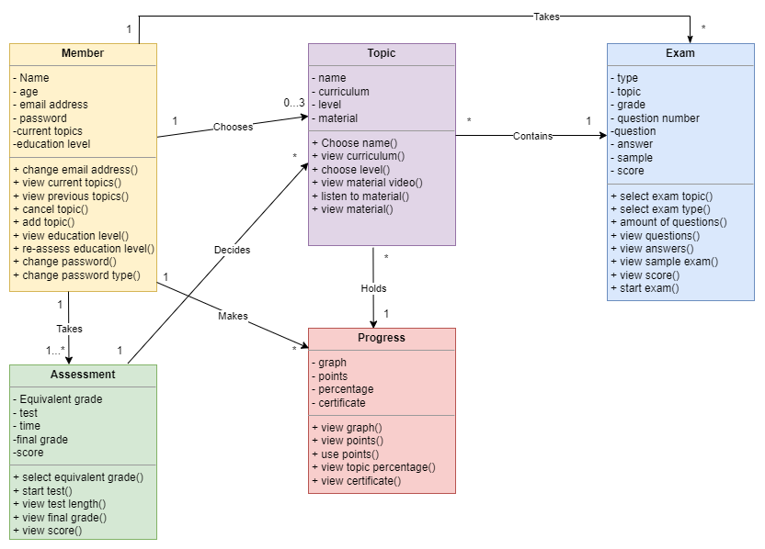

Class instances:

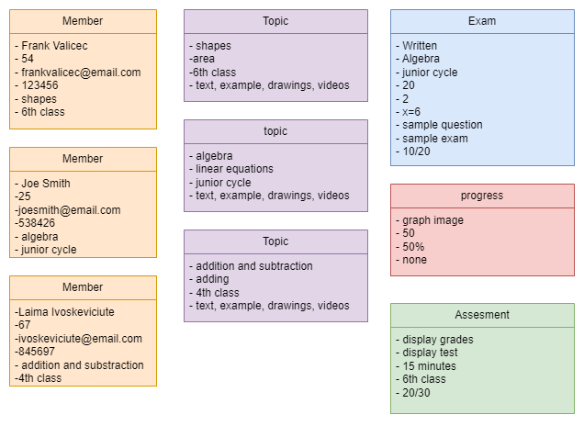

# User Prototypes

Prototype for Frank Valicec: he needs an option for the lesson to be read out loud so I decided to add a button that will read out the lesson and can be paused and reset as needed.

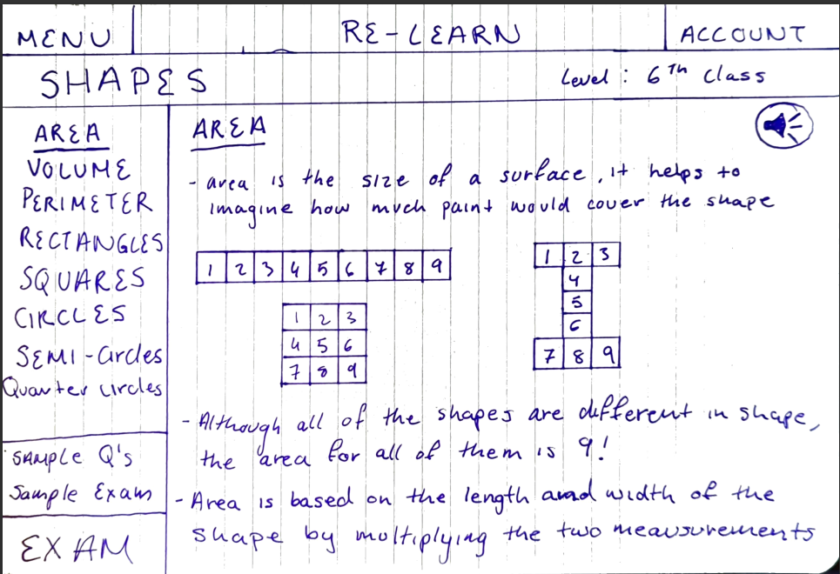

Prototype for Laima Ivoskeviciute, as she requires for exams and or advancements from the main curriculum’s question. I implemented easy access, small easy to navigate dropdowns as well as sample answers for this user to be able to correct themselves.

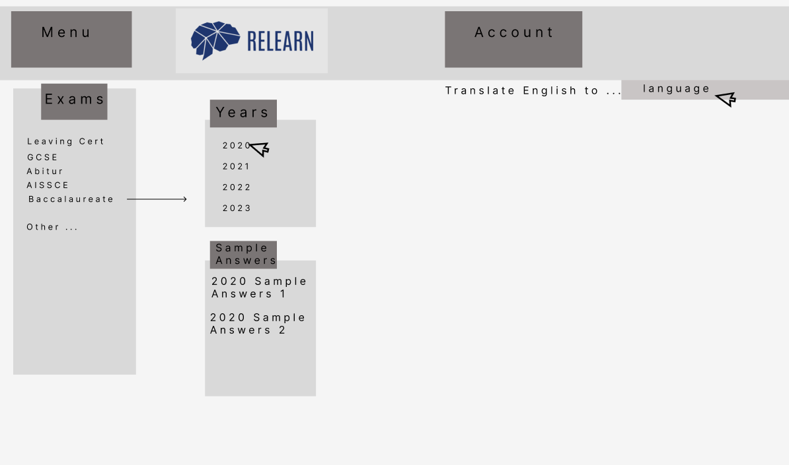

Changes Made:

-More readable to person

- No overloaded information, good for user that find difficulty with language

- Thought through that having a translating button would be helpful, see this a lot in other websites.

-Shows what types of curriculums are considered, went with the worldwide types first off.

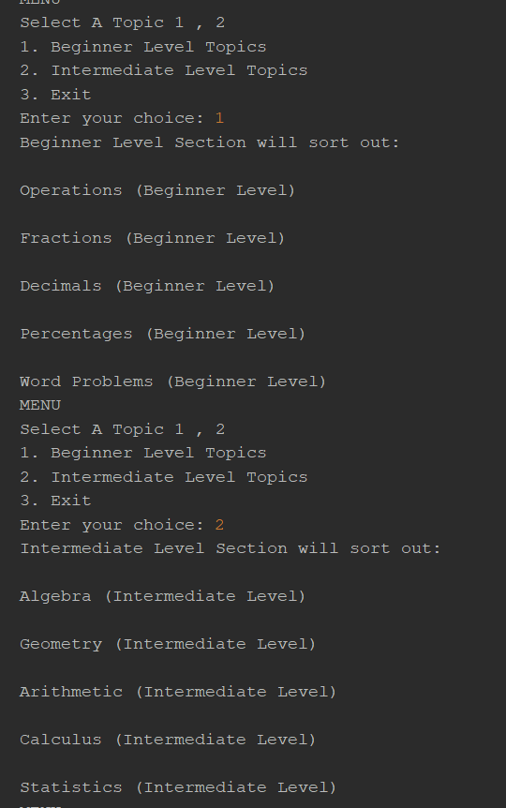

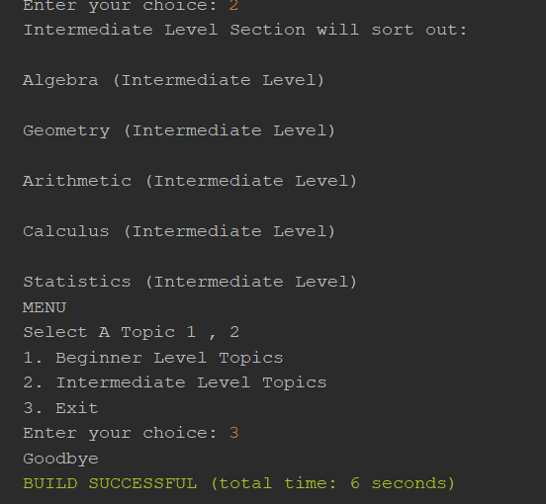

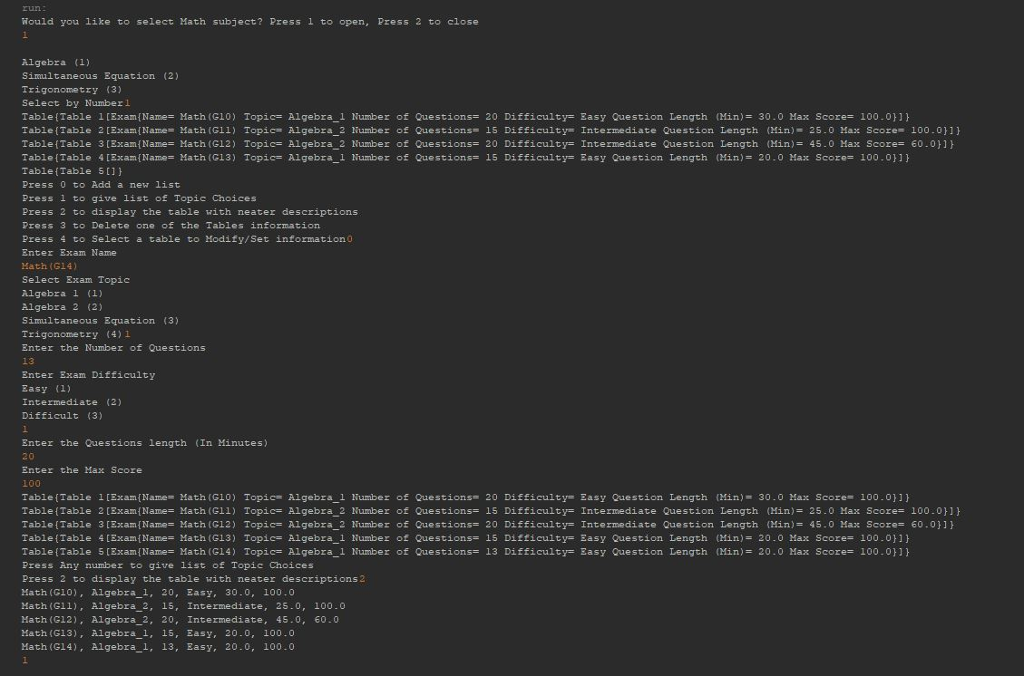

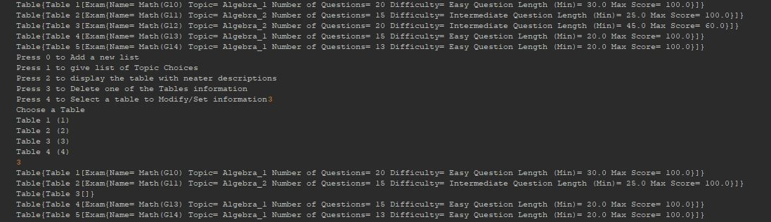

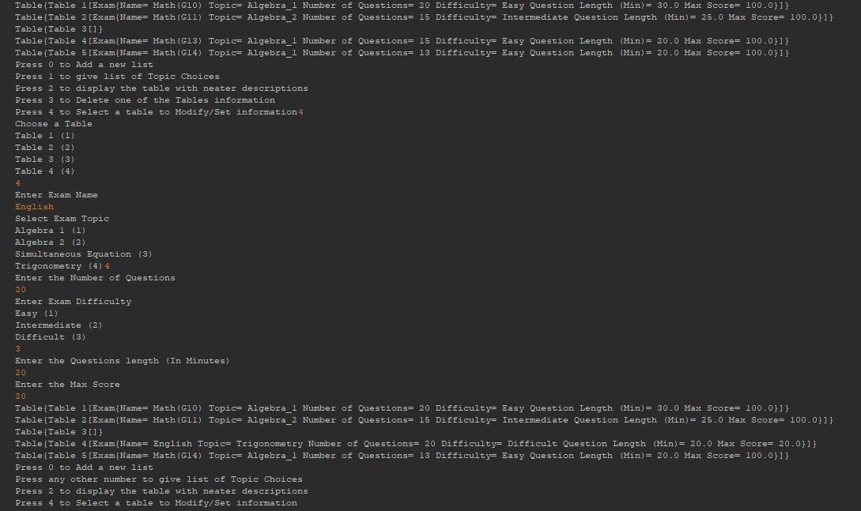

Prototype for Joe Smith, as he wants questions to be interactive, I created blocks containing right and wrong answers, to which the user can drag them and put them in the answer box

Prototype Diagram

Personal Evaluation: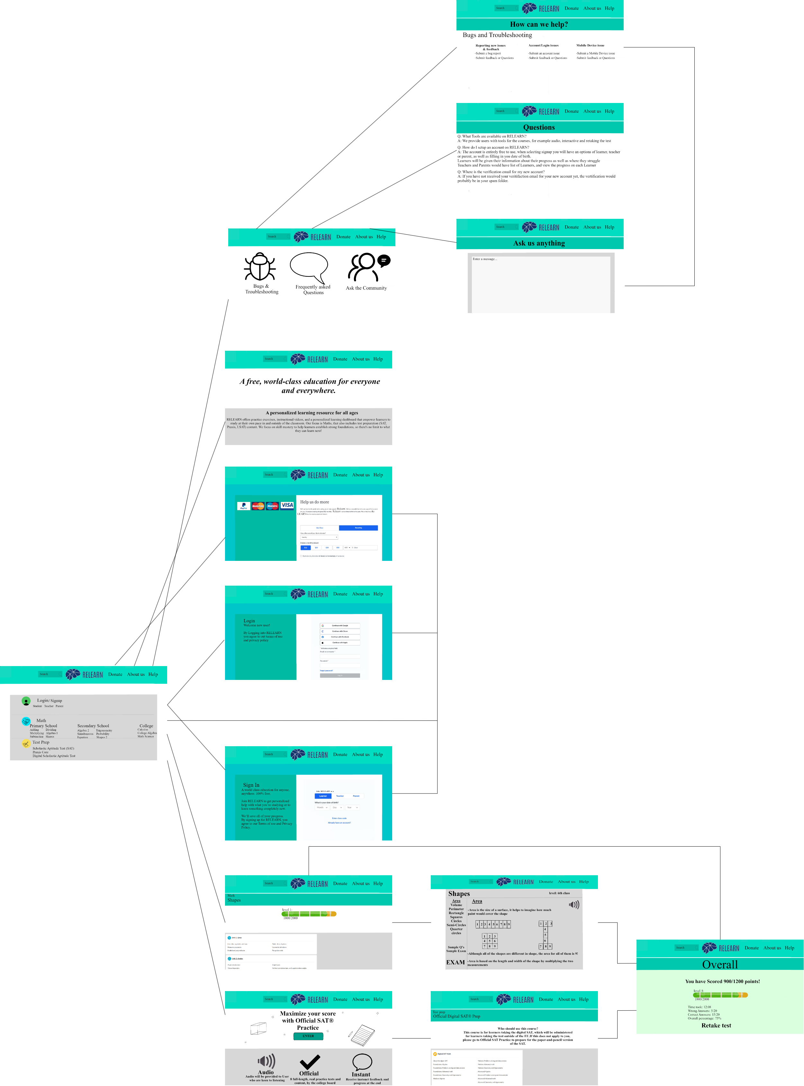

* The Exam/Test information and details should be accessible offline.

Customer Evaluation:

* Missing Account details on the main page, should delete login/signup once logged in.
* There should be a home button to be able to go back to the main menu.

Independent Evaluation:

* The navigation should be more simplified.
* Font sizes should be bigger for elderly users.
* There should be a settings option to change aspects of the website, for example, language, font size or Color-blind mode.

Recreated Prototype Diagram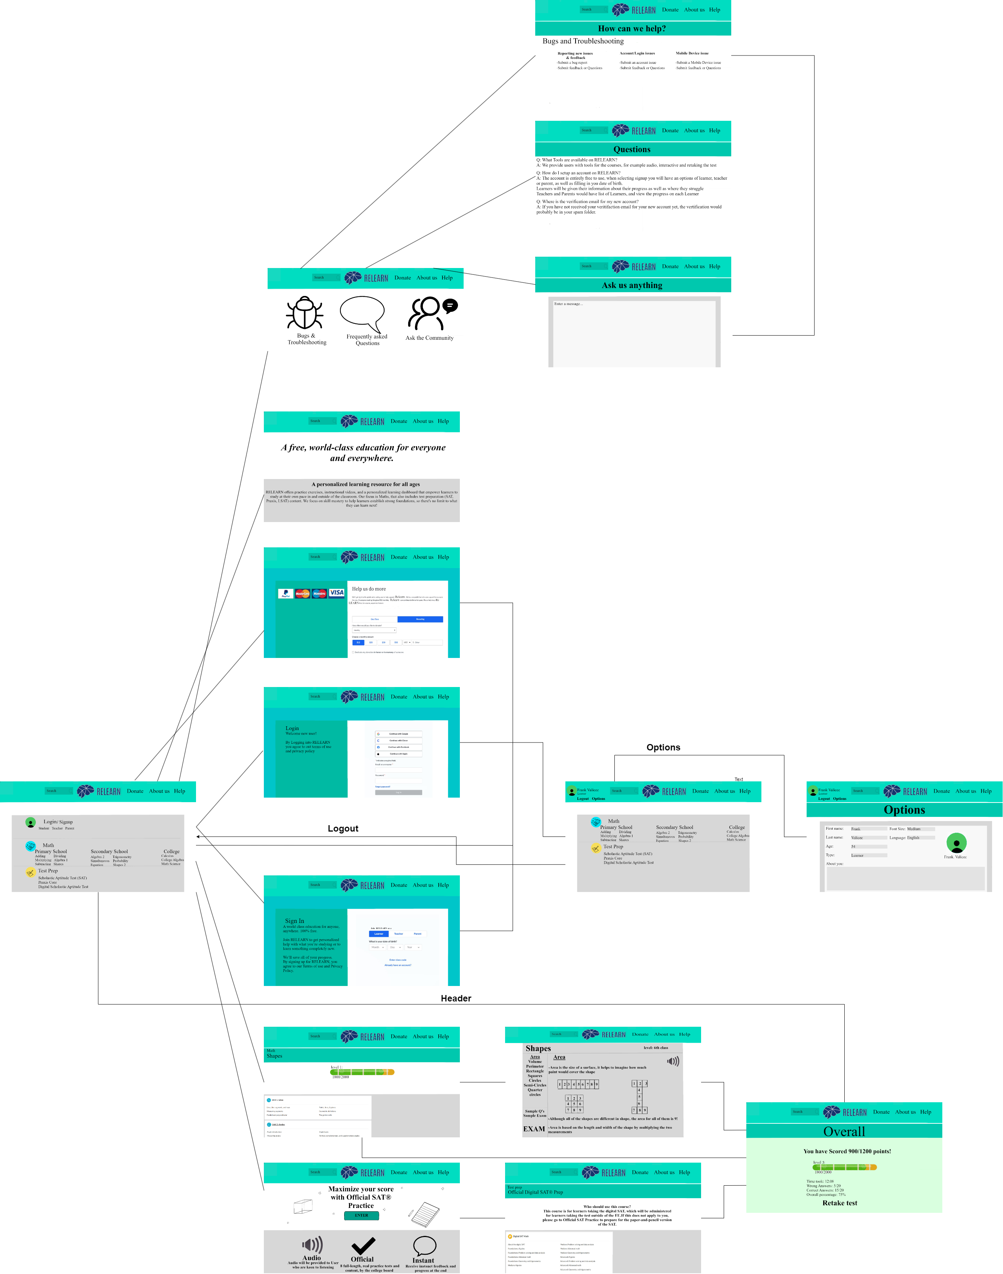

Test Case

Adding a table

Modifying a table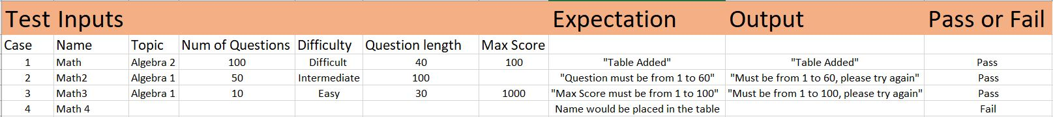

Selecting a Topic

